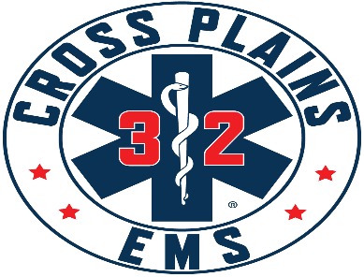

Cross Plains Area Emergency Medical Services District Board
Meeting Agenda
March 11, 2026 @ 7:00 p.m.
Town of Cross Plains Town Hall, 3734 County Hwy P

ToJoinByZoom:
https://us02web.zoom.us/j/81707632718?pwd=0bluGycQOPRq0cZ1LgaMG8SM0VcN68.1

To Join By Phone: 16469313860
Meeting ID: 817 0763 2718
Passcode: 295157

- Call to Order

- Roll Call

- Pledge of Allegiance

- Public Comment – This is an opportunity for anyone to address the Cross Plains EMS Board on any issue. Please observe the time limit of 3 minutes. While the Cross Plains EMS Board encourages input from residents, it may not discuss or act on any issue that is not duly noticed on the agenda. THOSE WISHING TO SPEAK DURING THE MEETING ARE ENCOURAGED TO REGISTER PRIOR THE START OF THE MEETING. YOU MAY ALSO REGISTER YOUR COMMENT BY SENDING AN EMAIL TO Chief@crossplainsems.com by 4:00PM ON THE DAY OF THE MEETING.

- Discussion/Action on Cross Plains EMS District Agreement

- Discussion/Action on New WISCOM Radios and the use of 2025 Surplus funds.

- Discussion/Action on using R32 for Interfacility Transports from Hospitals.

- Discussion/Action on Standby Agreement.

- 2026 License renewal and addition of R33 to Operational Plan

- R33 accident and Insurance update.

- Adjournment

