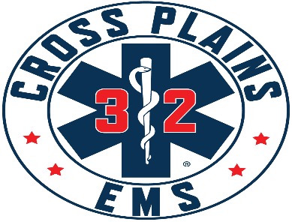

Cross Plains Area Emergency Medical Services District Board
Meeting Agenda
February 11, 2026 @ 7:00 p.m.
Town of Cross Plains Town Hall, 3734 County Hwy P and by Zoom
To Join by Zoom:
https://us02web.zoom.us/j/81707632718?pwd=0bluGycQOPRq0cZ1LgaMG8SM0VcN68.1
To Join By Phone: 16469313860
Meeting ID: 817 0763 2718
Passcode: 295157
- Call to Order.

- Roll Call.

- Pledge of Allegiance
IV. Public Comment – This is an opportunity for anyone to address the Cross Plains EMS Board on any issue. Please observe the time limit of 3 minutes. While the Cross Plains EMS Board encourages input from residents, it may not discuss or act on any issue that is not duly noticed on the agenda. THOSE WISHING TO SPEAK DURING THE MEETING ARE ENCOURAGED TO REGISTER PRIOR THE START OF THE MEETING. YOU MAY ALSO REGISTER YOUR COMMENT BY SENDING AN EMAIL TO Chief@crossplainsems.com by 4:00PM ON THE DAY OF THE MEETING.
- Discussion/Action on allocation of 2025 surplus of $55,166.99
VI. Discussion/Action Amendments to Cross Plains Area Emergency Medical Services District Agreement

