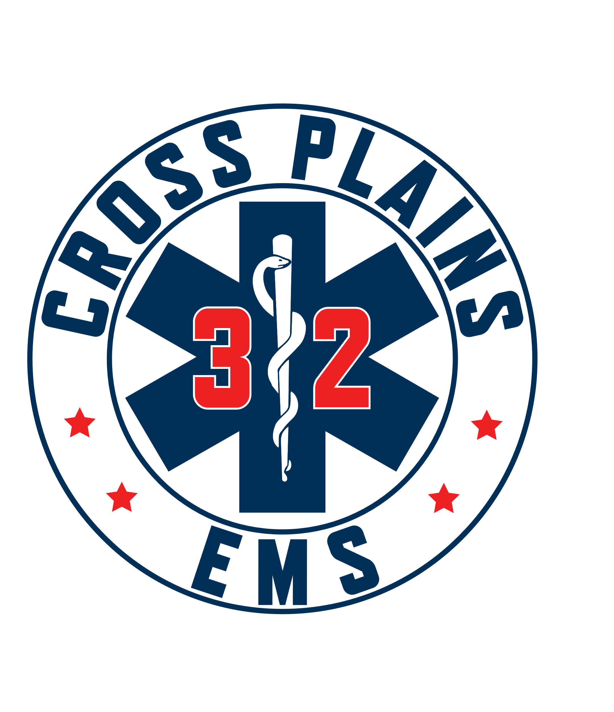 Cross Plains Area Emergency Medical Services District Board
Meeting Agenda for Wednesday February 26, 2025 @ 7:00 pm.
Cross Plains Berry Fire Department – 1501 Bourbon Road

- Call to order and Pledge of Allegiance.
Meeting called to order at 1900. Present are Greg Hyer, Dave Laufenberg, Jay Lengfeld, and Holly Ellickson. Absent: Mike Statz.

- Approval of Minutes from November 20, 2024 meeting.
Dave Laufenberg makes a motion to approve minutes from November 20, 2024 as written. Jay Lengfeld seconded. Motion Passes.

- Public Comment: This is an opportunity for anyone to address the EMS Board on any issue NOT on the current agenda. Please observe the time limit of 3 minutes. While the EMS Board encourages input from residents, it may not discuss or act on any issue that is not duly noticed on the agenda.
No Public Comments made.

- Agenda items from last meeting:
- Discussion/Action on Chief have cell phone paid for by the district. Dave Laufenberg makes a motion to approve a cell phone for the Chief. Jay Lengfeld seconded. Motion passes.

- Discussion/Action of Chief being off probation as of 01/24/2025. Probation salary was set at $70,000.00 per offer letter. Holly has completed probation as defined in the appointment letter. Jay Lengfeld makes a motion to move Holly from probation to a permanent position as Chief. Dave Lengfeld seconded. Motion passes.

- Financial Report:
- Discussion/Action of 2024 budget. The board reviewed and accepted this report.
- Discussion/Action on excess funds from 2024 budget.
- Chief’s Suggestions
Greg Hyer makes a motion to approve the Chief’s list as is except number 4. Greg states we should take the $45,000.00 plus $50,000.00 from the Capitol Account to go towards the new Ambulance. This would leave $25,000.00 in the Capitol Account. Dave Laufenberg seconds the motion. Discussion: Jay states that we should have budget amendments into the line items so this money can be tracked. Should also show in 2025 budget the total amount of surplus carried forward. Motion passes.
- Discussion/Action on checks written. Greg Hyer makes motion to approve checks as written. Jay seconded the motion. Motion passes.
- Discussion/Action on Visa bills from January. Greg Hyer reviewed the bill prior to the meeting.
- Discussion/Action on 2025 budget. Board members reviewed the budget thus far. Will look for above changes at next board meeting.

- Report from EMS Board Members:
- President
- Town of Berry
- Town of Springfield- Dave will check with the Town of Springfield if decisions have been made yet on territory lines.
- Village of Cross Plains

- Introduction of Dr. Charles Pearce, CPEMS Medical Director
Dr. Charles Pearce introduces himself to the board. He is a Cross Plains resident and has been CPAEMS Medical Director for the past 5 years. He states he is super impressed with the Cross Plains EMS and plans to be more involved. The chief and staff have some pretty great ideas and initiatives that are currently not being carried out anywhere else in the area. They are committed to the communities they serve, and Holly has done an excellent job in the past year as Chief.

- Discussion/Action of Dissolution of District by Village of Cross Plains.
The current agreement expired in 2022. The village of Cross Plains sent out a memo to board members a year or so ago stating the village has a finance committee investigating pulling out of the district and running their own ambulance. The village would still serve the Town of Berry, Town of Springfield, and Town of Cross Plains, but the Village of Cross Plains would have control over budget. The district agreement is outdated and needs to be updated; however, it does state that anyone pulling out from the district would need to give a 2-year notice. This means the Village of Cross Plains would need to give notice by December 1, 2025. Village staff are checking into a feasibility grant. The other issues that need to be discussed are Value Assessment/Population methodology, and evaluation of district and capital equipment. Village states they could do a 5-year revolving contract. Jay Lengfeld states there would be no changes in operations, but it would increase efficiency and cost.
Chief Ellickson states she is concerned about Village taking over as the towns could pull out and go with other agencies. This would have an impact on staff as we would have fewer calls, need fewer staff, and may not be able to keep volunteers. Jay Lengfeld states none of this would change as the village is growing and would still need the staff we currently have.

- EMS Chief’s Report.
- Update on new Rig and equipment.
Delivery date is still June of 2025. Equipment has been ordered that the Association is gifting to the district.
- Update on full-time staff and staffing numbers.
- Year-end numbers.
Visual presentation given on call volume, cost, Ambulance billing, Insurance payments, etc.

- Updates on CPEMS Association
Kelly Powell, CPEMS Association President states the Association is working on getting registered with the State of WI and will have to change from an Association to ta Corporation. They are registered as a non-profit, however not registered with the State. They are registered and have a tax-exempt number. Their 990 has been reported. Kelly will give a final update at the next meeting.

- Discussion and update on District One
Sounds like both Black Earth Fire and Mazomanie Fire will combine.

- Adjournment
Dave Laufenberg makes a motion to adjourn. Jay Lengfeld seconded the motion. Motion passed. The meeting ended at 2030.

People requiring an interpreter, materials or alternate formats or other accommodation to access this meeting are encouraged to contact the EMS Chief at 608-798-2720 at least 72 hours prior to the meeting.

Agenda approved by EMS Board President: Greg Hyer, Chair, Town of Cross Plains

