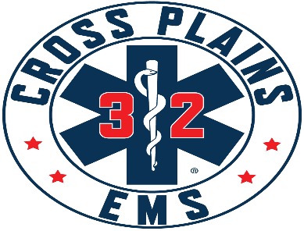Cross Plains Area Emergency Medical Services District Board
Meeting Agenda for January 21, 2026 @ 7:00 p.m.
Cross Plains Berry Fire Department -1505 Bourbon Road

- Call to Order

- Roll Call

- Pledge of Allegiance

- Approval of October 22, 2025 meeting minutes

- Discussion on District Agreement Revisions
Public Comment – This is an opportunity for anyone to address the Cross Plains EMS Board on any issue. Please observe the time limit of 3 minutes. While the Cross Plains EMS Board encourages input from residents, it may not discuss or act on any issue that is not duly noticed on the agenda. THOSE WISHING TO SPEAK DURING THE MEETING ARE ENCOURAGED TO REGISTER PRIOR THE START OF THE MEETING. YOU MAY ALSO REGISTER YOUR COMMENT BY SENDING AN EMAIL TO Chief@crossplainsems.com by 4:00PM ON THE DAY OF THE MEETING.

- Financial Reports:
a. Checks written 10/21/25-12/31/2025
b. Visa bills from October, November and December of 2025, previously approved by Greg Hyer
c. 4th quarter 2025 budget. Discuss/action regarding surplus.
d. 2026 budget
VII. POLICY CHANGES
- Discussion on District Agreement Revisions
- Action regarding Ride Along Policy
- Action regarding Fire Rehab Policy
- Action regarding Peer Support Policy
- what are we doing with R32, new AI policy and changing rates

- Report from EMS Board Members:
  - President – Town of Cross Plains
  - Vice President – Village of Cross Plains
  - Treasurer – Town of Berry
  - Town of Springfield

- Chief’s Report

- Adjournment

This meeting notice constitutes an official meeting of the above-mentioned group and was posted in accordance with all applicable laws related to Open Meetings Law. It is possible that members of and possibly a quorum of members of other governmental bodies of the municipality may be in attendance at the above-mentioned meeting to gather information. No action will be taken by any governmental body at the above stated meeting other than the governmental body specifically referred to above in this notice. Upon reasonable notice, efforts will be made to accommodate the needs of disabled individuals. For additional information or to request this service, contact the EMS Chief at (608) 798-2720 or chief@crossplainsems.com.

Agenda Approved by EMS Board President: Greg Hyer, Chair, Town of Cross Plains.

