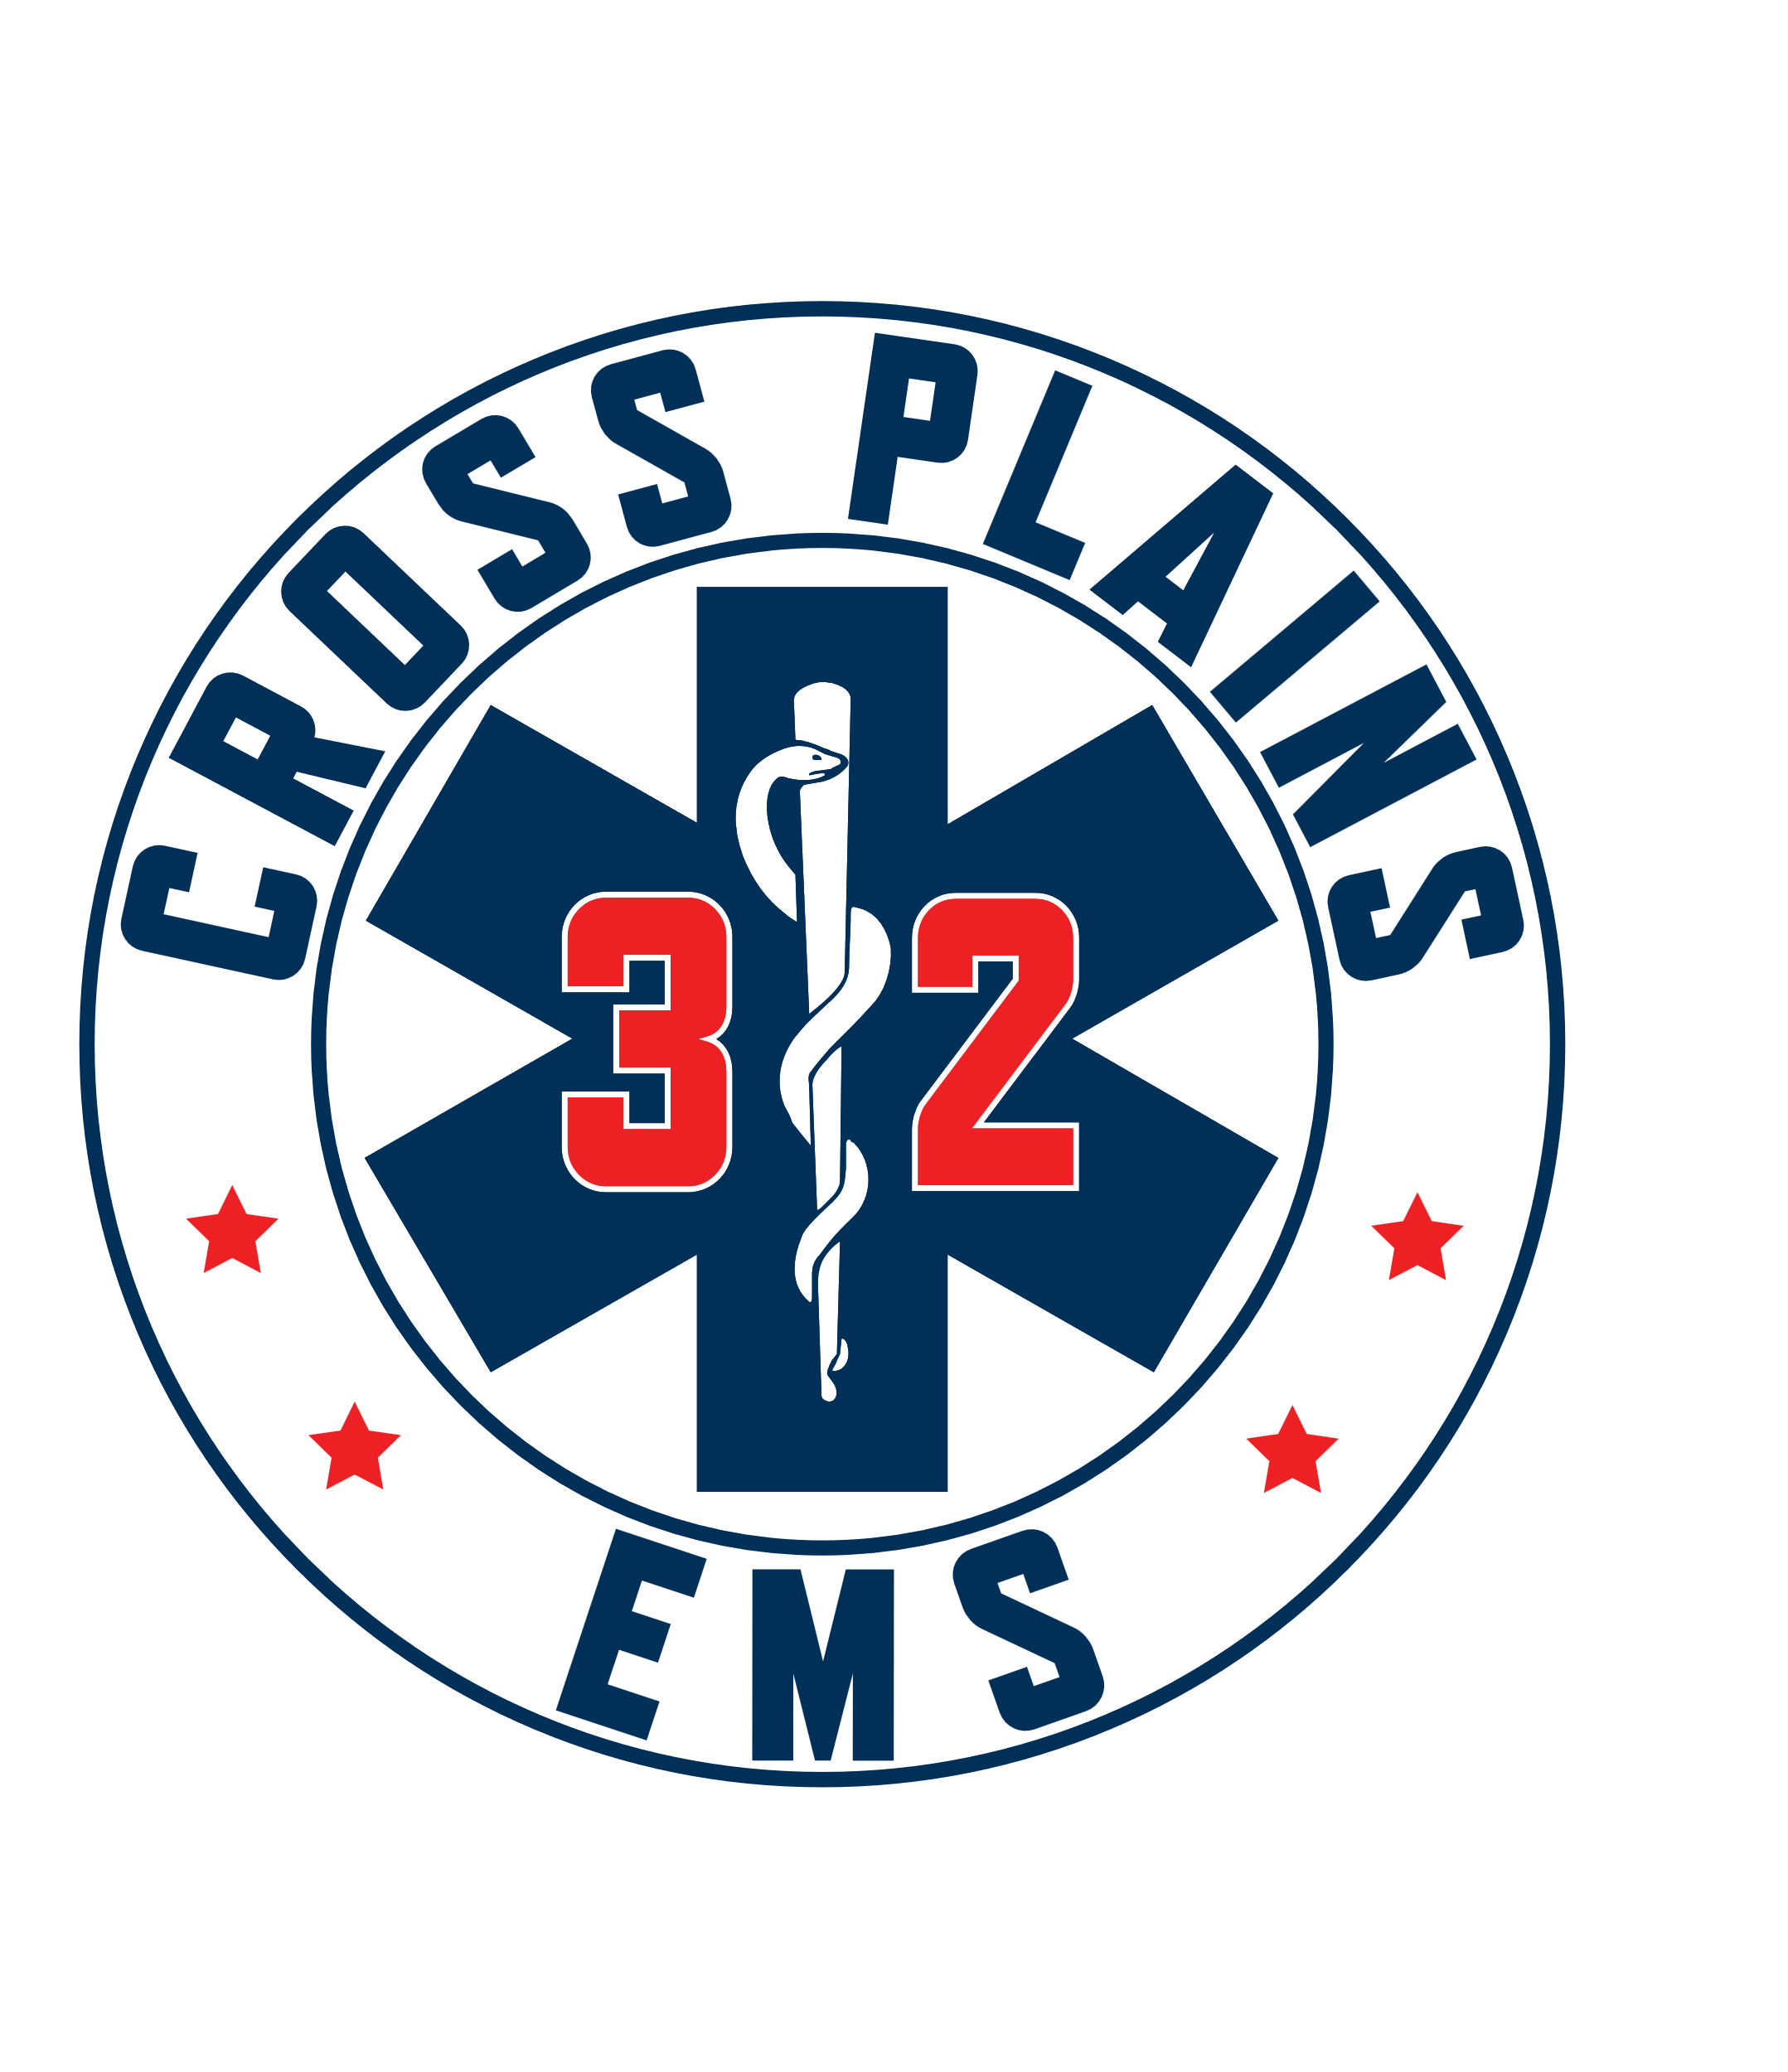 Cross Plains Area Emergency Medical Services
2027 Park Street, Cross Plains WI 53528 608-798-2720
__________________________________________________________________________

District Board Meeting Notice and Agenda
Wednesday, April 23, 2025, 7:00 pm
Cross Plains Fire Department – 1501 Bourbon St. – Main Level Conference Room

- Call to order and Roll Call. Meeting Called to order at 7 p.m. Present Greg Hyer, Jay Lengfeld, Dave Laufenberg, Mike Statz, Holly Ellickson and Brian Pitt.

- Pledge of Allegiance

- Approval of Minutes: Jay Lengfeld asks for clarification on last meeting minutes. Dave Laufenberg makes a motion to approve February 26, 2025, meeting minutes. Jay Lengfeld seconds this motion. Motion passes.

- Public Comment: This is an opportunity for anyone to address the EMS Board on any issue NOT on the current agenda. Please observe the time limit of 3 minutes. While the EMS Board encourages input from residents, it may not discuss or act on any issue that is not duly noticed on the agenda. NONE

- Population Presentation/Discussion: Sean Higgins. Sean states he gets numbers through Nextgen which Dane County 911 uses for address points. He also uses census numbers from 2020, building permits and the DOA numbers. DOA estimates are within 1%. He went back and counted block by block for household and to find multiplier for that block. Discussion on the methodology of numbers and multiplier per house used. The board has concerns with numbers and wonders if there is an underlying issue with multiplier or math used. Sean will go back and double check all of the numbers and share results through email. Once the board agrees on numbers to use, would consider using these numbers for a five- or ten-year period before updating.

- Cross Plains Area EMS Association update: President Kelly Powell. Kelly Powell is not in attendance tonight, but sends the following message: The Association has submitted the paperwork for the association to become a corporation. It is a 3-step process so once we get the first round of paperwork back, we will continue to move forward.

Culver’s is generously hosting a share night for EMS during EMS week on Tuesday May 20th from 5-8 pm. And they will be donating a portion of their proceeds from that night to EMS. We plan to put that towards the new defibrillator.

- Annual election of district officers: Discussion had by all board members that they will keep offices the same. Dave Laufenberg makes a motion to keep all offices the same. Jay Langfeld seconded this. Motion passed. President – Greg Hyer, Treasurer – Mike Statz, Secretary – Holly Ellickson.

- Financial Report:
  - Review of 1st Quarter financials. No questions or concerns at this time.
  - Discussion/Action on checks written from February through April 2025 – Dave Laufenberg makes a motion to approve checks written from February through April 2025. Mike Statz seconds this. Motion passes.
  - Discussion/Action on Visa Bill’s from February and March of 2025. Greg Hyer previously viewed these and approved them.

- Report from EMS Board Members:
a.) President – Town of Cross Plains. None
b.) Town of Berry- Mazomanie Fire and Black Earth Fire will be merging. They are currently evaluating which fire company owns what equipment and getting assed values.
c.) Town of Springfield – None.
d.) Village of Cross Plains – None.

- Update on new ambulance. Chief talks to Cyrea from Braun monthly. The current delivery date is set at late September 2025. All items that the CPEMS Association agreed to purchase and give to the district has been ordered. The only thing that has been paid for currently is radios.

- Chief’s Report

Dane county is having a survivors event for people who have been saved during a cardiac arrest. Cross Plains has a patient that was saved in 2024. If this patient agrees to come to celebration, the crew that helped save his/her life will be able to meet with him.
Katrina McKee, current member of the CPEMS has received EMT of the Year from the American Legion 3rd district. There will be a award ceremony this Saturday and her application will then move on to the State for consideration. Those results will be announced in June.
- MG&E Evaluation – Chief had asked MG&E to come out and do a Business Energy Assessment since the building is in need of some repairs. MG&E came out and did an evaluation of not only the station, but also the MG&E bills to see if we could decrease costs. MG&E states we are currently saving $52.71 by being on the Cg-3 time of use rate. We could consider installing a wi-fi-enabled thermostat and having only the Chief and Deputy Chief able to change the settings. We should continue with LED lighting thought building as light bulbs burn out. It was suggested that we have someone come out to check insulation levels and air sealing in all of our attics. This was done through Duerst Insulation. Duerst states we only have 6” of insulation and it should be more. There are areas that are not covered properly due to the wire work that was done and that attic doors are not sealed properly. The estimate was about $2,500.00.
- Computer and Network Evaluation – Disarc. Disarc was asked to do an evaluation since this has not been done in many years. Concern about HIPAA breaches and due to Medicare rules. Disarc found a computer at end of life, which needs to be replaced, and our firewall and security programs are old and outdated among other things. Estimate was given to update all computers, security, firewalls, etc. Holly is checking to see if this can be covered by FAP funds.
- FAP Funds – We were awarded $32,404.38 from the State. FAP funds have rules of what you can and cannot spend this money on. It is currently in it’s own account. Our current balance of FAP funds is just over $23,000.00. We have spent some of the funds on equipment: combi boards, updating some CPR equipment: AED Skill guides, Timers for the garage doors through R&R doors, and buying a couch and chairs downstairs. Holly has emails into the FAP fund to see if we can use some of this money for the Insulation needed and other building issues.
- Grants. We received $1,000 from Kwik Trip and $4,000 from Kalscheur Family Foundation.
- 2024 excess funds and what has been purchased – All money has been moved to line item’s agreed upon at last meeting.
- Parking at EMS – Holly is concerned that once next ambulance comes, staff will not have a place to park come winter. This may not be an issue for a few years, but Holly would like the board to be proactive and come up with a solution prior to problems happening. Suggest adding 6-8 parking spaces behind the building. The current rule is that EMS can not park in front of buildings if it is snowing 2 or more inches. We can no longer park in Bay’s if we have two rigs. We cannot park in the parking lot across from EMS as this is private and Holly did speak with owners, and she would appreciate it if no one parked their as they do not currently have enough parking spaces for current client’s. We can not park at the Post Office. Holly suggests that maybe we could call TDS to see if we could use their driveways. We rarely see any TDS trucks parked in that driveway. Jay Lengfeld states we could park at the public parking lot across from the Vessel. The board feels this is a issue that might affect us 3-4 days of a year.
- WI GEMT Payments – Holly show’s board some of the pages that will need to be filled out and what Medicaid is asking for. We will have to start in 2023 and move forward.
- Peer Support for First Responders in Cross Plains – Brian does a presentation on what we have set up for CPEMS. CPFD and CPPD have also joined to make sure all of our responders are taken care of. We have contracted with Healthy Minds.
- Community EMS Program – Presentation given by Brian along with a timeline of when this should start. Jay Lengfeld raises concern about billing everyone for this service. He feels that there should be two different policies. One for billing people who need medical attention and that there should be community support/outreach for people who just need support and to be connected to resources, such as our most vulnerable community members that have hording issues. Jay is worried that if we bill some of these people, they will no longer call us for help, or they will stop reaching out. All agree and we will make sure to show clearly in SOP’s who gets billed for what service and what services will be community outreach.
- UW Madison – Volunteers – Brian gives presentation on how CPEMS has partnered with UW Madison advisors for the EMT Experience program. This is the same program that Mt. Horeb runs, however, CPEMs will get 2 volunteers per year. Our first 2 people start this fall.

Jay Lengfeld makes a motion to move to closed session. Dave Laufenberg seconds this motion. Roll Call Vote: Jay Lengfeld – Yes, Dave Laufenberg – Yes, Mike Statz- Yes, Greg Hyer – Yes. Motion passes. The room is cleared and doors closed. Closed Session starts at 8:45 p.m.

- Closed session to discuss personnel.
The EMS Board will meet in closed session pursuant to 19.85 (1)(f) ) of Wisconsin Status to consider employment, promotion, compensation, or performance evaluation data of any public employee over which the governmental body has jurisdiction or exercises responsibility.

Greg Hyer makes a motion to return to Open Session at 9:03 p.m. Dave Laufenberg Seconds this. Motion passes.

- Adjournment: Mike Statz makes a motion to adjourn meeting at 9:05 p.m. Jay Lengfeld seconds this. Motion passes, meeting adjourned.

Persons requiring an interpreter, materials or alternate formats or other accommodation to access this meeting are encouraged to contact the EMS Chief at 608-798-2720 at least 72 hours prior to the meeting.

Agenda Approved by EMS Board President: Greg Hyer, Chair, Town of Cross Plains

