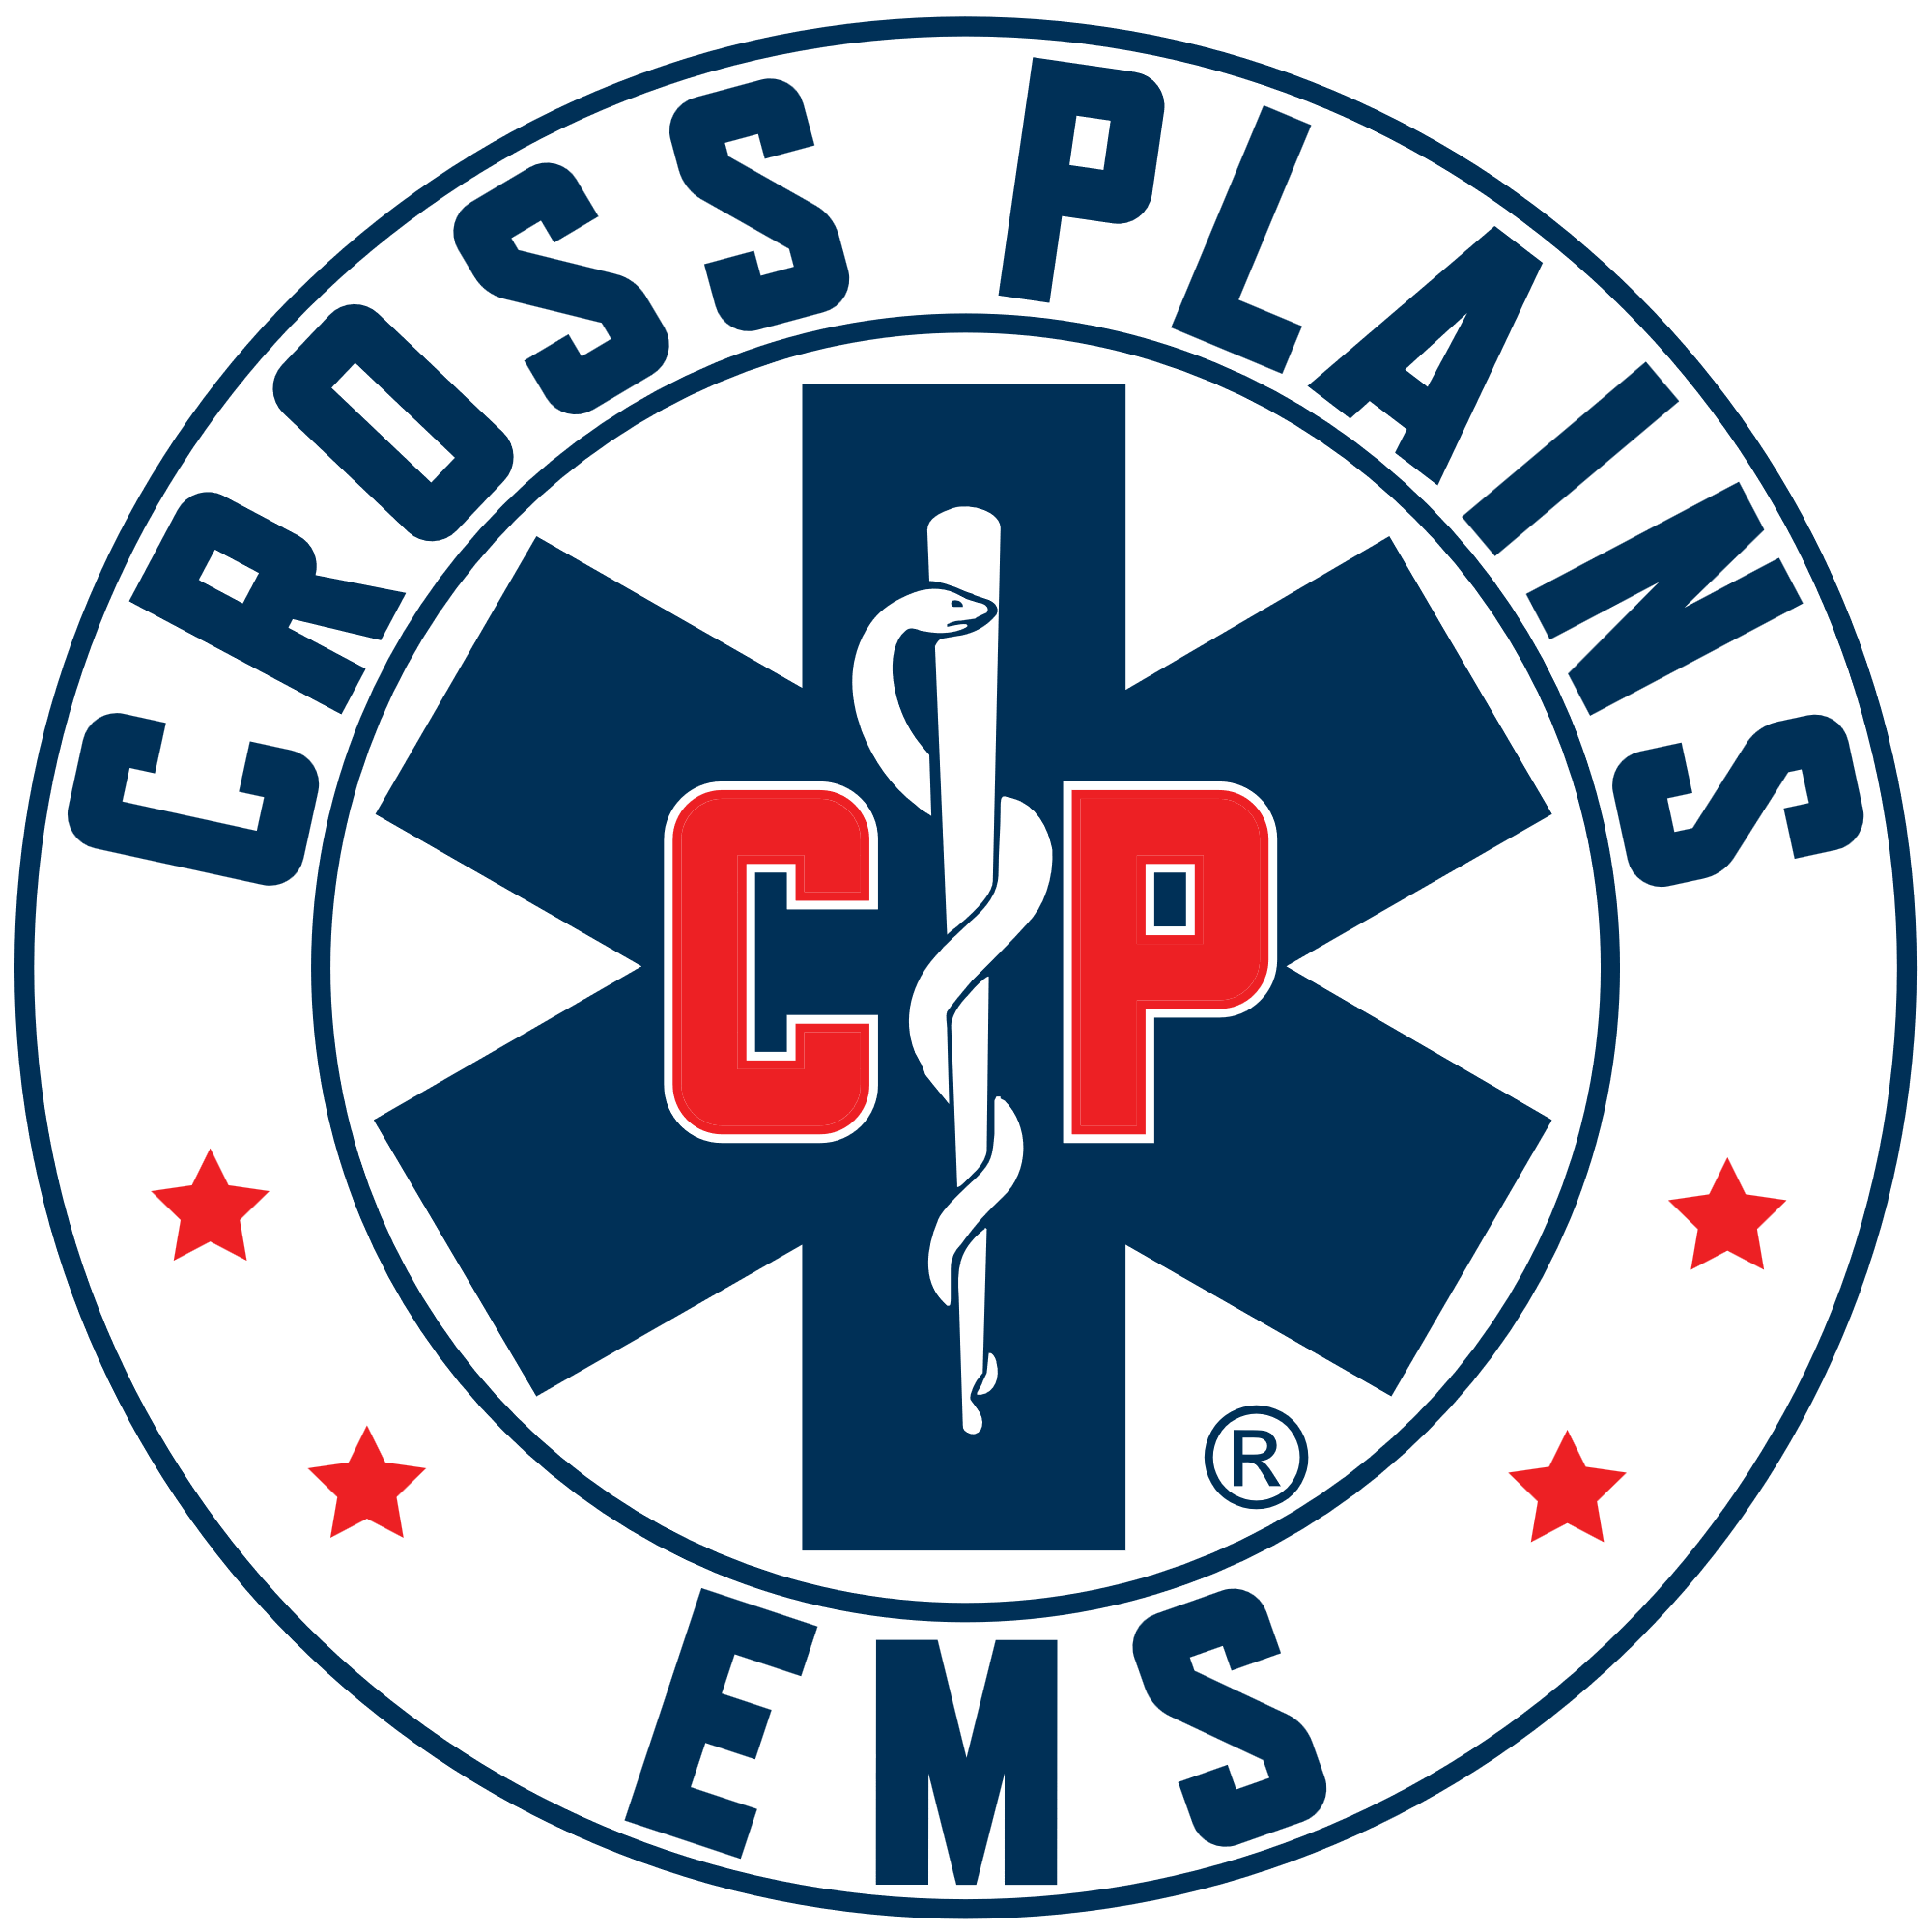 Cross Plains Area EMS District Meeting Agenda
July 15, 2026 at @ 7:00 p.m.
Town of Cross Plains Town Hall, 3734 County Hwy P
To join by Zoom:
http://us02web.zoom.us/j/81707632718?pwd=0bluGycQOPRq0cZ1LgaMG8SM0VcN68.1
To join by Phone: 16469313860
Meeting ID: 817 0763 2718
Passcode: 295157

- Call to Order

- Roll Call

- Pledge of Allegiance

- Public Comment: This is an opportunity for anyone to address the Cross Plains EMS Board on any issue. Please observe the time limit of 3 minutes. While the Cross Plains EMS Board encourages input from residents, it may not discuss or act on any issue that is not duly noticed on the agenda. Those wishing to speak during the meeting are encouraged to register prior the start of the meeting. You may also register your comment by sending an email to cheif@crossplainsems.com by 4:00 pm on the day of the meeting.

- Approval minutes from June 10, 2026.

- Discussion/Action on Financials
- Checks written from March to June 30, 2026.
- Visa bills for May, June and July, were previously approved by Greg Hyer.
- 2nd quarter 2026 budget
- 2027 budget draft
- Making Deputy Chief a Salary Position.

- Discussion/Action on wages for IFT and Community EMS. With review of handouts from Christie Mellott – PWW (Page, Wolfberg & Wirth, LLC)

- Discussion/Action for CPEMS Station Roof Estimates and Insurance.

- Discussion/Action for CPEMS Bay Floor

- Discussion/Action on District one plans and CPEMS Flex Medic

- Update on Computers/Electronics/HIPAA and Internet Safety.

- Adjournment.

